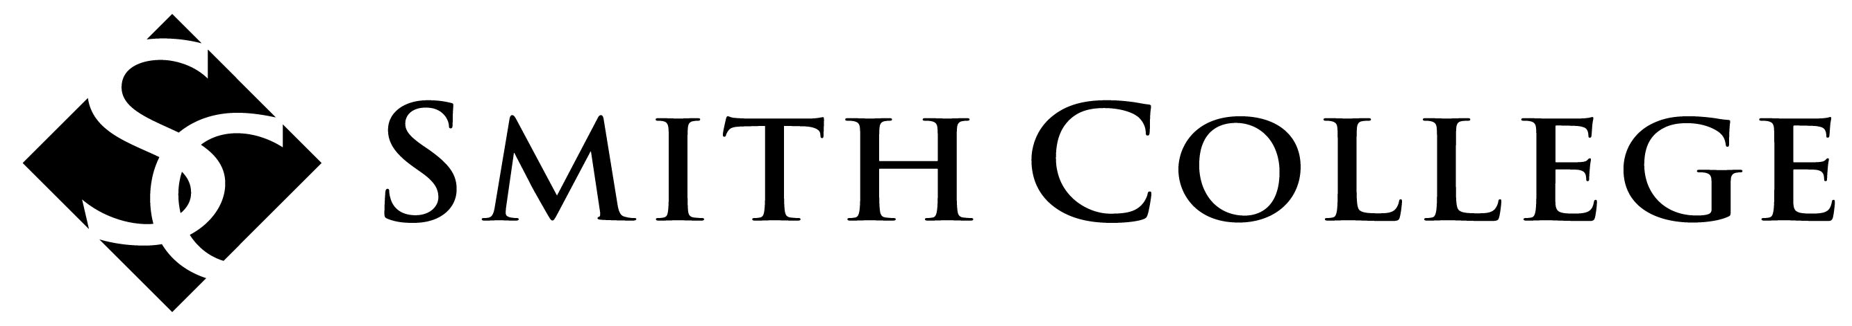
Museums
Concentration

Supervisor Evaluation Form
Student: Please complete the upper portion of this form and give it to your supervisor at the beginning of your internship, volunteer, or work experience.

Name: |  | Graduation Year:
Supervisor Name and Title:
Institution  Name: | Address:
 | Phone:
Begin and end dates:
Supervisor: Please complete the evaluation form below and return it to your student intern or employee at the end of her time working with you. Feel free to discuss this form with the student.

 | Needs Improvement | Proficient | Highly Commendable
Demonstrated understanding of position responsibilities
Managed time effectively to meet deadlines
Communicated well with other staff members
Demonstrated knowledge required to meet objectives
Completed required tasks as assigned by supervisor
Fulfilled the attendance requirements for the position

Student fulfilled the overall expectations for this position | YES NO

Additional Comments (please attach a separate sheet if needed):

Supervisor signature: Date:

Students: Submit this completed form to Russel Altamirano at SCMA (museduc@smith.edu, Campus address: Museum of Art, Tryon Hall).

