NEW RESEARCH METHODS COURSE IN OBSERVATIONAL ASTRONOMY
AST 341 Observational Techniques II, Spring Term 2018

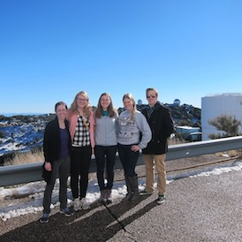
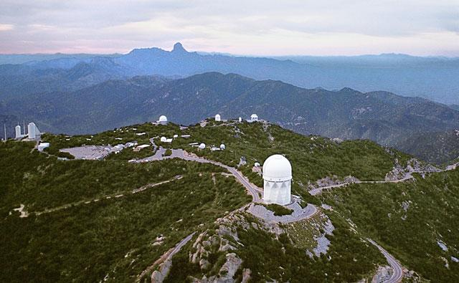
The course begins with an observing run at Kitt Peak National Observatory near Tucson, AZ in January 2018. The class will use the WIYN 0.9-meter telescope and Half Degree Imager CCD Camera to study variations in young low mass stars from a variety of processes: rotating star spots, chromospheric activity, mass accreting from a protoplanetary disk, and eclipsing companions. Each student will get their own data, and reduce and analyze it during weekly seminars through the semester, led by the instructor, Kimberly Ward-Duong. Scientific results will be presented in a poster session to the full Five College Astronomy Department at the end of the semester, and may result in co-authorship on a published paper.

Some experience with techniques of CCD imaging, photometry, astrometry, and statistical image analysis is expected, gained either in AST 337, another course, or previous research experience. The Five College Astronomy Department will cover the cost of the trip to the telescope, provided you commit to full participation in the class from January through May.

Enrollment is by permission of the instructor and is limited to 10-12 students. Interested students must submit a written application (see attached form), provide a current transcript, the name of one astronomy professor for a reference, and a personal statement that includes why you want to take this course and what your qualifications are. The course is 4 credits and will meet 3 hr/week through the semester, probably Wednesday evenings at Amherst College.

Course logistics:
- Prepare for observing prior to departure -- complete reading assignment on telescope, instrument manuals, science justification for observing proposal
- Observing at Kitt Peak National Observatory January 12-19
  - Students will be at the telescope in one of two 4-night shifts
- Class Seminar will meet once a week during spring term, 3 hr/wk, on Wednesday evenings from 7-10 pm. Each student will also be expected to work individually on their data for approximately 6 hours a week in order to complete the project.
- Last week of classes: Final project presentations in poster session to FCAD. No exam.

Application Form: AST 341 Observational Techniques II, Spring 2018
Due Nov 3, 2018

Name:

School:

Email address:

Year:

Major:

Courses in Astronomy:

Courses in Physics:

Experience with Computer Programming:

Have you taken AST337? If not, what previous experience qualifies you for this course?

____________________________________________________________________________________
If accepted for the course, are you prepared to sign a form saying you agree to complete the full semester of AST 341 in order to qualify for travel funding?

Do you have a preference for observing in the first or second half of the week of Jan 12-19?

____________________________________________________________________________________
Include with application: completed form, academic transcript, one page (or less) personal statement, name of astronomy professor who has agreed to write a reference for you.

Submit application to astronomy department at your school:
D. Dyar (MHC), S. Hameed (HC), K. Follette (AC), J. Lowenthal (SC), R. Snell (UMass)

